Chapter 2

Solution of Nonlinier Equations

  - Introduction

This chapter is concerned with the solution of a nonlinier equation f (x) = 0. While some nonlinier equation can be solved exactly, most can not.

If r is a real number such that f (r) = 0 then we say r is a root or solution of the equation f (x) = 0. We also call r a zero of the function f . If f (r) = 0 and f′(r) ≠ 0 then r is a simple root ( see Figure 2.1 )

r
x

Figure 2.1 A simple root r

However, if f (x) = ( x-r )^{m} g(x) where g(r) ≠ 0 and m > 1 is an integer, we say that r is a root of multiplicity or order m. In this case f^{(k)} (r) = 0 for k = 0, 1, …, m – 1 and f^{(m)} (r) ≠ 0.
r
x
r
x

m > 1, odd m > 1, even

Figure 2.2 Roots r of multiplicity m > 1.
The methods for solving nonlinier equations are iterative methods where a sequence of approximations to the solution is calculated. The iteration is terminated once a sufficiently accurate estimate is found.
An equation f(x) = 0 may have no roots, a finite number of roots, or infinitely many roots. The number of roots and their approximate value can often be found using a sketch.

▌Worked Example 2.1.1 Determine the approximate values of the roots of χ² + e^{χ} = 4.

The equation can be written as e^{x} = 4 - χ², so we sketch the functions y = e^{x} and y = 4 — x² on the same axes and estimate the x coordinate of the points of intersection.

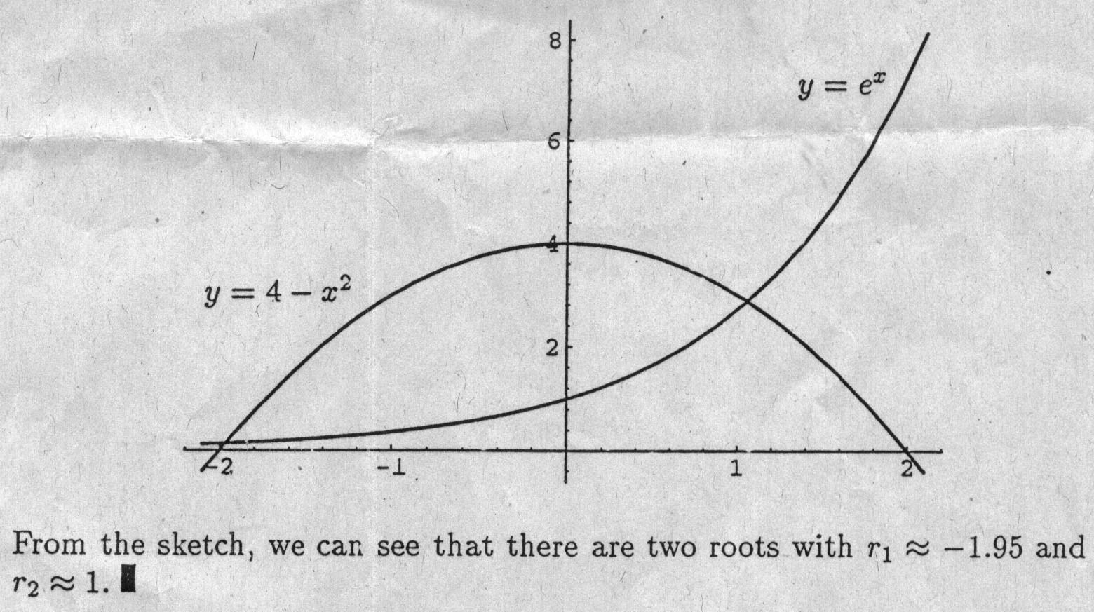

Self Assessment Exercises 2.1
- Using a sketch, determine the number and approximate value of the roots of cos χ - χ + 1 = 0.
- Determine the approximate value of all of the roots of e^{-χ} + cos x = 0.

2.2 Bisection method

If f (x) is continuous on [a, b] and f (c) and f (b) have opposite sign (f(a)f(b) < 0) then there is at least one root r Є (a, b). Suppose there is only one root in the interval. If the interval is halved, the subinterval which contains the root can be determined, and this process continued until the root is known to sufficient accuracy. In Figure 2.3 the original interval is denoted by (a₀,b₀)> the next interval by (a₁,b₁) and so on.
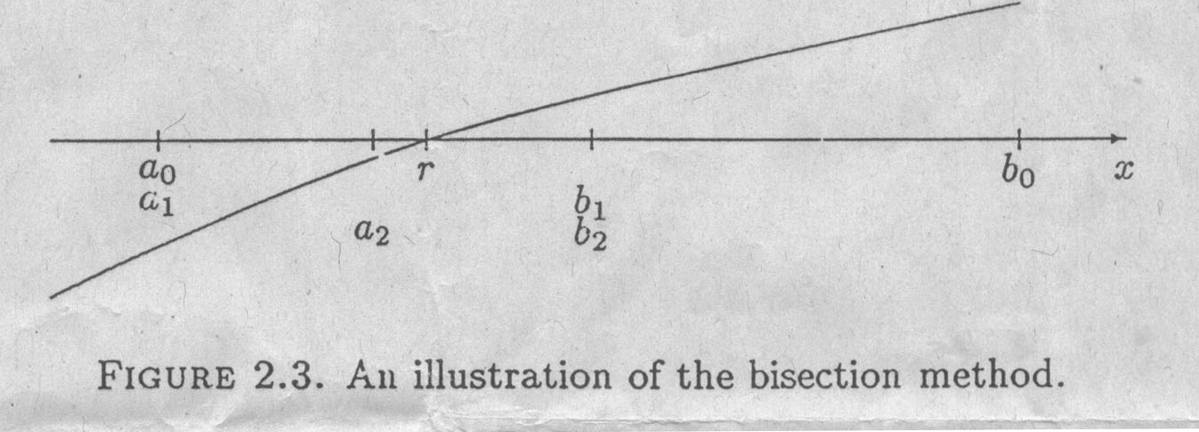

Suppose that we know that the root lies in the interval (a, b) We calculate c = (a+b)/2 (the midpoint of the interval), and if f (b) f (c) < 0 then r Є (c, b) so a is replaced by c; otherwise r Є (a, c) so b is replaced by c. We now have an interval which is half as

Long and still contains the root. This bisection of the interval is repeated until we can estimate the root to the required qccuracy.
At each stage we take c as the current estimate of the root. Suppose that an estimate of the root is required such that$\left|\text{error}\right|$$ε$, where $ε$ is a given tolerance. It can be seen from the following figure that r can not be further from c that the distance of b from c, that is $\left|r−c\right|$b-c so the iteration is terminated when b-c$ε$.

a r c b

Figure 2.4. At any stage of the bisection method the distance tween r and c must be b-c.
Simple bisection algorithm
- INPUT a,b and toletance $ε$
- Calculate f(b)
- Calculate c=(a+b)/2 & f(c)
- If b-c$ε$ or f(c)=0 go to 7
- If f (b)f(c)<0 then set a=c else set b=c & f(b)=f(c)
- Go to 3
- OUTPUT “Root=c” and stop

Worked Example 2.2.1 Use the bisection method to find the root of z-1=$e^{−x}$that lies in the interval (1.1.4) to a tolerance of 0.02.

Let f(x)=x-1-e${}^{−x}$. Puttring the results in a table gives:

a b c f(b) f(c) f(b)f(c) action
1 1.4 1.2 +0.15 -0.10 <0 a=c
1.2 1.4 1.3 +0.15 -0.027 >0 b=c,f(b)=f(c)
1.2 1.3 1.25 +0.027 -0.037 <0 a=c
1.25 1.3 1.275 +0.027 -0.0044 <0 a=c
1.275 1.3 1.2875

The iteration is terminated becsuse b-c=0.0125 which is smaller than the tolerance 0.02. The estimate of the root is r1.2875; it is known that r$∈$[1.275,1.3].
Only one function evaluation is need for each iteration of bisection method, although this is not clear from the algorithm as given. The product f(b)f(c) could result in underflow since each term will become small as the root is approached. Both of these issues are addressed in the following algorithm, which also has a check that the given interval is valid:

Improved bisection algorithm
- INPUT a, b and tolerance $ε$
- Calculate sfb = f(b) / $\left|f(b)\right|$
- If sfb * f(a) >0 then OUTPUT “ Invalid interval “ and stop
- Calculate c = ( a + b ) / 2 and fc = f (c)
- If b – c $ε$ or fc = 0 go to 8.
- If sbfx < 0 then set a = c else set b = c & sfb = fc / $f(c)$
- Go to 4
- OUTPUT “ Root = c “ and stop

The use of the command go to is often discourage ( and even does not exist in some computer languanges ). An alternative is to use either a repeat . . until or a do while construct.

Convergence of the bisection method

Denoting the original interval by ( a_{o},b_{o} ) and succeeding ones by ( a_{n},b_{n} ), n = 1, 2, . . .
b₁ – a₁ = $\frac{1}{2}$( b_{o} – a_{o} )
b₂ – a₂ = $\frac{1}{2}$( b₁ – a₁ ) = $\frac{1}{4}$( b_{o} – a_{o} )
b₃ – a₃ = $\frac{1}{2}$( b₂ – a₂ ) = $\frac{1}{8}$( b_{o} – a_{o} )
.
.
.

so clearly
b_{n} – a_{n} = $\frac{1}{2^{n}}$( b_{o} – a_{o} )
Now since c_{n} = ( b_{n} + a_{n} ) / 2,

$\left|r−c_{n}\right|≤$ b_{n} – c_{n}
= $\frac{1}{2}$( b_{n} – a_{n} )
= $\frac{1}{2^{n+1}}$ ( b_{o} – a_{o} )
So c_{n} $→r$as n $→$ ~ . Thus the bisection method converges for any initial interval containing a root ( or an old numbet of roots ).

Further, $\left|r−c_{n}\right|≤$ $ε$ if $\frac{1}{2^{n+1}}$ ( b_{o} – a_{o} ) $ε$, and this inequality holds
$⇔2^{n+1}≥\frac{b_{o}−a_{o}}{ε}$

$⇔(n+1)\text{log}2≥\text{log}\left(\frac{b_{o}−a_{o}}{ε}\right)$

$⇔n≥\frac{\text{log}\left(\frac{b_{o}−a_{o}}{ε}\right)}{\text{log}2}−1$.

Note that the number of iteration is independent of the function.

Worked Example 2.2.2 How many iterations of the bisection method are required to find the solution of $x−1−e^{x}=0$ to 4 decimal places if the initial interval (1,1,5) is used?

A tolerance of $ε=5×{\text{10}}^{−5}$ (or smaller) is required to ensure 4 decimal place accuracy. Now $a_{0}=1$ and $b_{0}=1\text{.}5$ so
$n≥\frac{\text{log}(\frac{b_{0}−a_{0}}{ε})}{\text{log}2}$- 1
$=\frac{\text{log}(\frac{1\text{.}5−1}{5×{\text{10}}^{−5}})}{\text{log}2}$-1
$\text{12}\text{.}\text{29}$

At least 13 iterations are needed to ensure 4 decimal place accuracy.

Self Assessment Exercises 2.2

- Beginning with the interval [0,$π/2$] carry out 3 iterations of the bisection method to find an estimate of the root of $x=0\text{.}8+0\text{.}2\text{Sinx}$
- Use the bisection method with $ε=0\text{.}\text{05}$ to find the solution of $x=2\text{Sinx}$that lies between $x=1$and $x=2$
- Give a bound for the error of the estimate of the solution after 5 iterrations of the bisection method of initial values $a=−2$ and $b=1\text{.}6$ are used.
- Determine the number of iterations required by the bisection method to find the root of $x−2\text{Sinx}=0$ that lies between $x=1$ and $x=2$ for the tolerance $ε={\text{10}}^{−6}$

2.3 Fixed point iteration

Suppose that $x=g(x)$ is a rearrangement of $f(x)=0$ .Then $f(r)=0⇔r=g(r)$,and r is called a fixed point of the function g. A fixed point can sometimes be found using the fixed point iteration ( or simple iteration, method of successive substitusion)

$x_{n−1}=g(x_{n})$ n = 0,1,…,

Given some initial estimate $x$ of r. A convergent iteration is shown in Figure 2.5. However, the iteration may diverge, as shown in Figure 2.6.

Convergence of fixed point iteration

Denote the error of $x_{n+1}$ by $e_{n+1}=r−x_{n+1}$ and since $r=g(r)$ and $x_{n+1}=g(x_{n})$
$e_{n+1}=g(r)−g(x_{n})$
$=g^{'}(ε_{n})(r−x_{n})$ Mean Value Theorem, $ε_{n}$ between r and $x_{n}$
$=g^{'}(ε_{n})e_{n}$

y=x
y

y=g(x)
g(x₀)=x₁

r x₂ x₁ x₀ x

Figure 2.5. An example of a convergent fixed point iteration x_{n+1} = g(x_{n}).

y
y=x

y=g(x)

x₂ x₀ r x₁ x

Figure 2.6. An example of a divergent iteration x_{n+1} = g(x_{n}).

