Curve Fit

Notes
Output Created |  | 24-AUG-2017 11:21:43
Comments
Input | Data | D:\Google Drive\ELEX17\CD\Bab 6\NonLinier_Bab 6.sav
Input | Active Dataset | DataSet1
Input | Filter | <none>
Input | Weight | <none>
Input | Split File | <none>
Input | N of Rows in Working Data File | 15
Missing Value Handling | Definition of Missing | User-defined missing values are treated as missing.
Missing Value Handling | Cases Used | Cases with a missing value in any variable are not used in the analysis.
Syntax |  | CURVEFIT  /VARIABLES=PI WITH Waktu  /CONSTANT  /MODEL=LINEAR LOGARITHMIC QUADRATIC EXPONENTIAL  /PRINT ANOVA  /PLOT FIT  /ID=No.
Resources | Processor Time | 00:00:00.42
Resources | Elapsed Time | 00:00:00.35
Use | From | First observation
Use | To | Last observation
Predict | From | First Observation following the use period
Predict | To | Last observation
Time Series Settings (TSET) | Amount of Output | PRINT = DEFAULT
Time Series Settings (TSET) | Saving New Variables | NEWVAR = NONE
Time Series Settings (TSET) | Maximum Number of Lags in Autocorrelation or Partial Autocorrelation Plots | MXAUTO = 16
Time Series Settings (TSET) | Maximum Number of Lags Per Cross-Correlation Plots | MXCROSS = 7
Time Series Settings (TSET) | Maximum Number of New Variables Generated Per Procedure | MXNEWVAR = 60
Time Series Settings (TSET) | Maximum Number of New Cases Per Procedure | MXPREDICT = 1000
Time Series Settings (TSET) | Treatment of User-Missing Values | MISSING = EXCLUDE
Time Series Settings (TSET) | Confidence Interval Percentage Value | CIN = 95
Time Series Settings (TSET) | Tolerance for Entering Variables in Regression Equations | TOLER = .0001
Time Series Settings (TSET) | Maximum Iterative Parameter Change | CNVERGE = .001
Time Series Settings (TSET) | Method of Calculating Std. Errors for Autocorrelations | ACFSE = IND
Time Series Settings (TSET) | Length of Seasonal Period | Unspecified
Time Series Settings (TSET) | Variable Whose Values Label Observations in Plots | Unspecified
Time Series Settings (TSET) | Equations Include | CONSTANT

Model Description
Model Name |  | MOD_9
Dependent Variable | 1 | Prognostic Index
Equation | 1 | Linear
Equation | 2 | Logarithmic
Equation | 3 | Quadratic
Equation | 4 | Exponentialª
Independent Variable |  | Lama di rawat
Constant |  | Included
Variable Whose Values Label Observations in Plots |  | No
Tolerance for Entering Terms in Equations |  | .0001

a. The model requires all non-missing values to be positive.

Case Processing Summary
 | N
Total Cases | 15
Excluded Casesª | 0
Forecasted Cases | 0
Newly Created Cases | 0

a. Cases with a missing value in any variable are excluded from the analysis.

Variable Processing Summary
 |  | Variables
 |  | Dependent | Independent
 |  | Prognostic Index | Lama di rawat
Number of Positive Values |  | 15 | 15
Number of Zeros |  | 0 | 0
Number of Negative Values |  | 0 | 0
Number of Missing Values | User-Missing | 0 | 0
Number of Missing Values | System-Missing | 0 | 0

Prognostic Index

Linear

Model Summary
R | R Square | Adjusted R Square | Std. Error of the Estimate
.941 | .886 | .877 | 5.891

The independent variable is Lama di rawat.

ANOVA
 | Sum of Squares | df | Mean Square | F | Sig.
Regression | 3492.139 | 1 | 3492.139 | 100.617 | .000
Residual | 451.195 | 13 | 34.707
Total | 3943.333 | 14

The independent variable is Lama di rawat.

Coefficients
 | Unstandardized Coefficients |  | Standardized Coefficients | t | Sig.
 | B | Std. Error | Beta | t | Sig.
Lama di rawat | -.753 | .075 | -.941 | -10.031 | .000
(Constant) | 46.460 | 2.762 |  | 16.820 | .000

Logarithmic

Model Summary
R | R Square | Adjusted R Square | Std. Error of the Estimate
.983 | .965 | .963 | 3.241

The independent variable is Lama di rawat.

ANOVA
 | Sum of Squares | df | Mean Square | F | Sig.
Regression | 3806.798 | 1 | 3806.798 | 362.458 | .000
Residual | 136.535 | 13 | 10.503
Total | 3943.333 | 14

The independent variable is Lama di rawat.

Coefficients
 | Unstandardized Coefficients |  | Standardized Coefficients | t | Sig.
 | B | Std. Error | Beta | t | Sig.
ln(Lama di rawat) | -15.966 | .839 | -.983 | -19.038 | .000
(Constant) | 72.283 | 2.704 |  | 26.733 | .000

Quadratic

Model Summary
R | R Square | Adjusted R Square | Std. Error of the Estimate
.991 | .982 | .979 | 2.455

The independent variable is Lama di rawat.

ANOVA
 | Sum of Squares | df | Mean Square | F | Sig.
Regression | 3870.991 | 2 | 1935.495 | 321.054 | .000
Residual | 72.343 | 12 | 6.029
Total | 3943.333 | 14

The independent variable is Lama di rawat.

Coefficients
 | Unstandardized Coefficients |  | Standardized Coefficients | t | Sig.
 | B | Std. Error | Beta | t | Sig.
Lama di rawat | -1.710 | .125 | -2.139 | -13.704 | .000
Lama di rawat ** 2 | .015 | .002 | 1.237 | 7.927 | .000
(Constant) | 55.822 | 1.649 |  | 33.848 | .000

Exponential

Model Summary
R | R Square | Adjusted R Square | Std. Error of the Estimate
.977 | .955 | .952 | .179

The independent variable is Lama di rawat.

ANOVA
 | Sum of Squares | df | Mean Square | F | Sig.
Regression | 8.893 | 1 | 8.893 | 276.379 | .000
Residual | .418 | 13 | .032
Total | 9.311 | 14

The independent variable is Lama di rawat.

Coefficients
 | Unstandardized Coefficients |  | Standardized Coefficients | t | Sig.
 | B | Std. Error | Beta | t | Sig.
Lama di rawat | -.038 | .002 | -.977 | -16.625 | .000
(Constant) | 56.665 | 4.766 |  | 11.890 | .000

The dependent variable is ln(Prognostic Index).

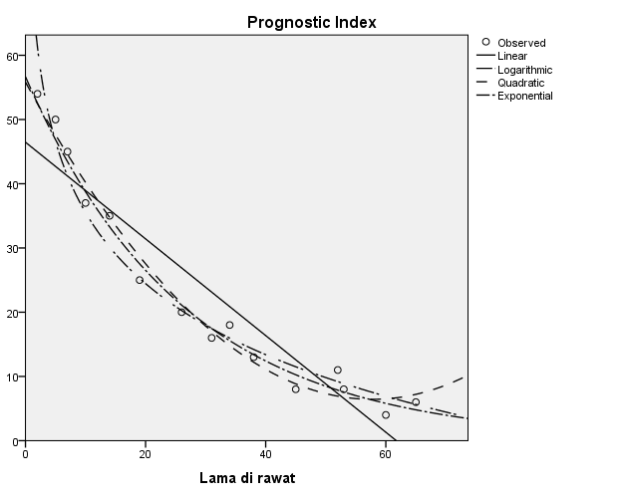

Curve Fit

Notes
Output Created |  | 24-AUG-2017 11:31:17
Comments
Input | Data | D:\Google Drive\ELEX17\CD\Bab 6\NonLinier_Bab 6.sav
Input | Active Dataset | DataSet1
Input | Filter | <none>
Input | Weight | <none>
Input | Split File | <none>
Input | N of Rows in Working Data File | 15
Missing Value Handling | Definition of Missing | User-defined missing values are treated as missing.
Missing Value Handling | Cases Used | Cases with a missing value in any variable are not used in the analysis.
Syntax |  | CURVEFIT  /VARIABLES=PI WITH Waktu  /CONSTANT  /MODEL=LINEAR  /PRINT ANOVA  /PLOT FIT  /ID=No.
Resources | Processor Time | 00:00:00.33
Resources | Elapsed Time | 00:00:00.23
Use | From | First observation
Use | To | Last observation
Predict | From | First Observation following the use period
Predict | To | Last observation
Time Series Settings (TSET) | Amount of Output | PRINT = DEFAULT
Time Series Settings (TSET) | Saving New Variables | NEWVAR = NONE
Time Series Settings (TSET) | Maximum Number of Lags in Autocorrelation or Partial Autocorrelation Plots | MXAUTO = 16
Time Series Settings (TSET) | Maximum Number of Lags Per Cross-Correlation Plots | MXCROSS = 7
Time Series Settings (TSET) | Maximum Number of New Variables Generated Per Procedure | MXNEWVAR = 60
Time Series Settings (TSET) | Maximum Number of New Cases Per Procedure | MXPREDICT = 1000
Time Series Settings (TSET) | Treatment of User-Missing Values | MISSING = EXCLUDE
Time Series Settings (TSET) | Confidence Interval Percentage Value | CIN = 95
Time Series Settings (TSET) | Tolerance for Entering Variables in Regression Equations | TOLER = .0001
Time Series Settings (TSET) | Maximum Iterative Parameter Change | CNVERGE = .001
Time Series Settings (TSET) | Method of Calculating Std. Errors for Autocorrelations | ACFSE = IND
Time Series Settings (TSET) | Length of Seasonal Period | Unspecified
Time Series Settings (TSET) | Variable Whose Values Label Observations in Plots | Unspecified
Time Series Settings (TSET) | Equations Include | CONSTANT

Model Description
Model Name |  | MOD_10
Dependent Variable | 1 | Prognostic Index
Equation | 1 | Linear
Independent Variable |  | Lama di rawat
Constant |  | Included
Variable Whose Values Label Observations in Plots |  | No

Case Processing Summary
 | N
Total Cases | 15
Excluded Casesª | 0
Forecasted Cases | 0
Newly Created Cases | 0

a. Cases with a missing value in any variable are excluded from the analysis.

Variable Processing Summary
 |  | Variables
 |  | Dependent | Independent
 |  | Prognostic Index | Lama di rawat
Number of Positive Values |  | 15 | 15
Number of Zeros |  | 0 | 0
Number of Negative Values |  | 0 | 0
Number of Missing Values | User-Missing | 0 | 0
Number of Missing Values | System-Missing | 0 | 0

Prognostic Index

Linear

Model Summary
R | R Square | Adjusted R Square | Std. Error of the Estimate
.941 | .886 | .877 | 5.891

The independent variable is Lama di rawat.

ANOVA
 | Sum of Squares | df | Mean Square | F | Sig.
Regression | 3492.139 | 1 | 3492.139 | 100.617 | .000
Residual | 451.195 | 13 | 34.707
Total | 3943.333 | 14

The independent variable is Lama di rawat.

Coefficients
 | Unstandardized Coefficients |  | Standardized Coefficients | t | Sig.
 | B | Std. Error | Beta | t | Sig.
Lama di rawat | -.753 | .075 | -.941 | -10.031 | .000
(Constant) | 46.460 | 2.762 |  | 16.820 | .000

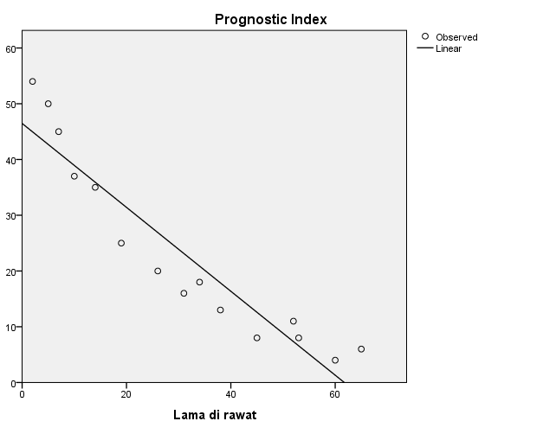

Curve Fit

Notes
Output Created |  | 24-AUG-2017 11:32:02
Comments
Input | Data | D:\Google Drive\ELEX17\CD\Bab 6\NonLinier_Bab 6.sav
Input | Active Dataset | DataSet1
Input | Filter | <none>
Input | Weight | <none>
Input | Split File | <none>
Input | N of Rows in Working Data File | 15
Missing Value Handling | Definition of Missing | User-defined missing values are treated as missing.
Missing Value Handling | Cases Used | Cases with a missing value in any variable are not used in the analysis.
Syntax |  | CURVEFIT  /VARIABLES=PI WITH Waktu  /CONSTANT  /MODEL=LOGARITHMIC  /PRINT ANOVA  /PLOT FIT  /ID=No.
Resources | Processor Time | 00:00:00.80
Resources | Elapsed Time | 00:00:00.30
Use | From | First observation
Use | To | Last observation
Predict | From | First Observation following the use period
Predict | To | Last observation
Time Series Settings (TSET) | Amount of Output | PRINT = DEFAULT
Time Series Settings (TSET) | Saving New Variables | NEWVAR = NONE
Time Series Settings (TSET) | Maximum Number of Lags in Autocorrelation or Partial Autocorrelation Plots | MXAUTO = 16
Time Series Settings (TSET) | Maximum Number of Lags Per Cross-Correlation Plots | MXCROSS = 7
Time Series Settings (TSET) | Maximum Number of New Variables Generated Per Procedure | MXNEWVAR = 60
Time Series Settings (TSET) | Maximum Number of New Cases Per Procedure | MXPREDICT = 1000
Time Series Settings (TSET) | Treatment of User-Missing Values | MISSING = EXCLUDE
Time Series Settings (TSET) | Confidence Interval Percentage Value | CIN = 95
Time Series Settings (TSET) | Tolerance for Entering Variables in Regression Equations | TOLER = .0001
Time Series Settings (TSET) | Maximum Iterative Parameter Change | CNVERGE = .001
Time Series Settings (TSET) | Method of Calculating Std. Errors for Autocorrelations | ACFSE = IND
Time Series Settings (TSET) | Length of Seasonal Period | Unspecified
Time Series Settings (TSET) | Variable Whose Values Label Observations in Plots | Unspecified
Time Series Settings (TSET) | Equations Include | CONSTANT

Model Description
Model Name |  | MOD_11
Dependent Variable | 1 | Prognostic Index
Equation | 1 | Logarithmic
Independent Variable |  | Lama di rawat
Constant |  | Included
Variable Whose Values Label Observations in Plots |  | No

Case Processing Summary
 | N
Total Cases | 15
Excluded Casesª | 0
Forecasted Cases | 0
Newly Created Cases | 0

a. Cases with a missing value in any variable are excluded from the analysis.

Variable Processing Summary
 |  | Variables
 |  | Dependent | Independent
 |  | Prognostic Index | Lama di rawat
Number of Positive Values |  | 15 | 15
Number of Zeros |  | 0 | 0
Number of Negative Values |  | 0 | 0
Number of Missing Values | User-Missing | 0 | 0
Number of Missing Values | System-Missing | 0 | 0

Prognostic Index

Logarithmic

Model Summary
R | R Square | Adjusted R Square | Std. Error of the Estimate
.983 | .965 | .963 | 3.241

The independent variable is Lama di rawat.

ANOVA
 | Sum of Squares | df | Mean Square | F | Sig.
Regression | 3806.798 | 1 | 3806.798 | 362.458 | .000
Residual | 136.535 | 13 | 10.503
Total | 3943.333 | 14

The independent variable is Lama di rawat.

Coefficients
 | Unstandardized Coefficients |  | Standardized Coefficients | t | Sig.
 | B | Std. Error | Beta | t | Sig.
ln(Lama di rawat) | -15.966 | .839 | -.983 | -19.038 | .000
(Constant) | 72.283 | 2.704 |  | 26.733 | .000

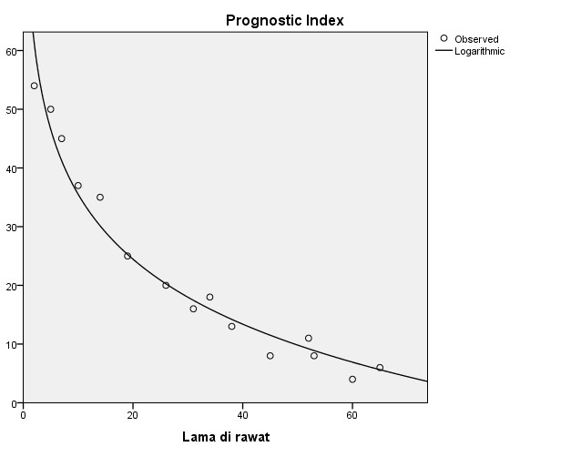

Curve Fit

Notes
Output Created |  | 24-AUG-2017 11:32:57
Comments
Input | Data | D:\Google Drive\ELEX17\CD\Bab 6\NonLinier_Bab 6.sav
Input | Active Dataset | DataSet1
Input | Filter | <none>
Input | Weight | <none>
Input | Split File | <none>
Input | N of Rows in Working Data File | 15
Missing Value Handling | Definition of Missing | User-defined missing values are treated as missing.
Missing Value Handling | Cases Used | Cases with a missing value in any variable are not used in the analysis.
Syntax |  | CURVEFIT  /VARIABLES=PI WITH Waktu  /CONSTANT  /MODEL=QUADRATIC  /PRINT ANOVA  /PLOT FIT  /ID=No.
Resources | Processor Time | 00:00:00.52
Resources | Elapsed Time | 00:00:00.28
Use | From | First observation
Use | To | Last observation
Predict | From | First Observation following the use period
Predict | To | Last observation
Time Series Settings (TSET) | Amount of Output | PRINT = DEFAULT
Time Series Settings (TSET) | Saving New Variables | NEWVAR = NONE
Time Series Settings (TSET) | Maximum Number of Lags in Autocorrelation or Partial Autocorrelation Plots | MXAUTO = 16
Time Series Settings (TSET) | Maximum Number of Lags Per Cross-Correlation Plots | MXCROSS = 7
Time Series Settings (TSET) | Maximum Number of New Variables Generated Per Procedure | MXNEWVAR = 60
Time Series Settings (TSET) | Maximum Number of New Cases Per Procedure | MXPREDICT = 1000
Time Series Settings (TSET) | Treatment of User-Missing Values | MISSING = EXCLUDE
Time Series Settings (TSET) | Confidence Interval Percentage Value | CIN = 95
Time Series Settings (TSET) | Tolerance for Entering Variables in Regression Equations | TOLER = .0001
Time Series Settings (TSET) | Maximum Iterative Parameter Change | CNVERGE = .001
Time Series Settings (TSET) | Method of Calculating Std. Errors for Autocorrelations | ACFSE = IND
Time Series Settings (TSET) | Length of Seasonal Period | Unspecified
Time Series Settings (TSET) | Variable Whose Values Label Observations in Plots | Unspecified
Time Series Settings (TSET) | Equations Include | CONSTANT

Model Description
Model Name |  | MOD_12
Dependent Variable | 1 | Prognostic Index
Equation | 1 | Quadratic
Independent Variable |  | Lama di rawat
Constant |  | Included
Variable Whose Values Label Observations in Plots |  | No
Tolerance for Entering Terms in Equations |  | .0001

Case Processing Summary
 | N
Total Cases | 15
Excluded Casesª | 0
Forecasted Cases | 0
Newly Created Cases | 0

a. Cases with a missing value in any variable are excluded from the analysis.

Variable Processing Summary
 |  | Variables
 |  | Dependent | Independent
 |  | Prognostic Index | Lama di rawat
Number of Positive Values |  | 15 | 15
Number of Zeros |  | 0 | 0
Number of Negative Values |  | 0 | 0
Number of Missing Values | User-Missing | 0 | 0
Number of Missing Values | System-Missing | 0 | 0

Prognostic Index

Quadratic

Model Summary
R | R Square | Adjusted R Square | Std. Error of the Estimate
.991 | .982 | .979 | 2.455

The independent variable is Lama di rawat.

ANOVA
 | Sum of Squares | df | Mean Square | F | Sig.
Regression | 3870.991 | 2 | 1935.495 | 321.054 | .000
Residual | 72.343 | 12 | 6.029
Total | 3943.333 | 14

The independent variable is Lama di rawat.

Coefficients
 | Unstandardized Coefficients |  | Standardized Coefficients | t | Sig.
 | B | Std. Error | Beta | t | Sig.
Lama di rawat | -1.710 | .125 | -2.139 | -13.704 | .000
Lama di rawat ** 2 | .015 | .002 | 1.237 | 7.927 | .000
(Constant) | 55.822 | 1.649 |  | 33.848 | .000

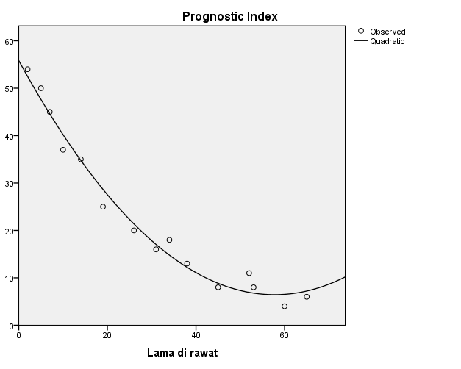

Curve Fit

Notes
Output Created |  | 24-AUG-2017 11:34:50
Comments
Input | Data | D:\Google Drive\ELEX17\CD\Bab 6\NonLinier_Bab 6.sav
Input | Active Dataset | DataSet1
Input | Filter | <none>
Input | Weight | <none>
Input | Split File | <none>
Input | N of Rows in Working Data File | 15
Missing Value Handling | Definition of Missing | User-defined missing values are treated as missing.
Missing Value Handling | Cases Used | Cases with a missing value in any variable are not used in the analysis.
Syntax |  | CURVEFIT  /VARIABLES=PI WITH Waktu  /CONSTANT  /MODEL=EXPONENTIAL  /PRINT ANOVA  /PLOT FIT  /ID=No.
Resources | Processor Time | 00:00:00.33
Resources | Elapsed Time | 00:00:00.23
Use | From | First observation
Use | To | Last observation
Predict | From | First Observation following the use period
Predict | To | Last observation
Time Series Settings (TSET) | Amount of Output | PRINT = DEFAULT
Time Series Settings (TSET) | Saving New Variables | NEWVAR = NONE
Time Series Settings (TSET) | Maximum Number of Lags in Autocorrelation or Partial Autocorrelation Plots | MXAUTO = 16
Time Series Settings (TSET) | Maximum Number of Lags Per Cross-Correlation Plots | MXCROSS = 7
Time Series Settings (TSET) | Maximum Number of New Variables Generated Per Procedure | MXNEWVAR = 60
Time Series Settings (TSET) | Maximum Number of New Cases Per Procedure | MXPREDICT = 1000
Time Series Settings (TSET) | Treatment of User-Missing Values | MISSING = EXCLUDE
Time Series Settings (TSET) | Confidence Interval Percentage Value | CIN = 95
Time Series Settings (TSET) | Tolerance for Entering Variables in Regression Equations | TOLER = .0001
Time Series Settings (TSET) | Maximum Iterative Parameter Change | CNVERGE = .001
Time Series Settings (TSET) | Method of Calculating Std. Errors for Autocorrelations | ACFSE = IND
Time Series Settings (TSET) | Length of Seasonal Period | Unspecified
Time Series Settings (TSET) | Variable Whose Values Label Observations in Plots | Unspecified
Time Series Settings (TSET) | Equations Include | CONSTANT

Model Description
Model Name |  | MOD_13
Dependent Variable | 1 | Prognostic Index
Equation | 1 | Exponentialª
Independent Variable |  | Lama di rawat
Constant |  | Included
Variable Whose Values Label Observations in Plots |  | No

a. The model requires all non-missing values to be positive.

Case Processing Summary
 | N
Total Cases | 15
Excluded Casesª | 0
Forecasted Cases | 0
Newly Created Cases | 0

a. Cases with a missing value in any variable are excluded from the analysis.

Variable Processing Summary
 |  | Variables
 |  | Dependent | Independent
 |  | Prognostic Index | Lama di rawat
Number of Positive Values |  | 15 | 15
Number of Zeros |  | 0 | 0
Number of Negative Values |  | 0 | 0
Number of Missing Values | User-Missing | 0 | 0
Number of Missing Values | System-Missing | 0 | 0

Prognostic Index

Exponential

Model Summary
R | R Square | Adjusted R Square | Std. Error of the Estimate
.977 | .955 | .952 | .179

The independent variable is Lama di rawat.

ANOVA
 | Sum of Squares | df | Mean Square | F | Sig.
Regression | 8.893 | 1 | 8.893 | 276.379 | .000
Residual | .418 | 13 | .032
Total | 9.311 | 14

The independent variable is Lama di rawat.

Coefficients
 | Unstandardized Coefficients |  | Standardized Coefficients | t | Sig.
 | B | Std. Error | Beta | t | Sig.
Lama di rawat | -.038 | .002 | -.977 | -16.625 | .000
(Constant) | 56.665 | 4.766 |  | 11.890 | .000

The dependent variable is ln(Prognostic Index).

