Explore

Notes
Output Created |  | 01-MAR-2017 09:54:41
Comments
Input | Data | D:\Google Drive\ELEX17\CD\Normalitas_Bab 1.sav
Input | Active Dataset | DataSet1
Input | Filter | <none>
Input | Weight | <none>
Input | Split File | <none>
Input | N of Rows in Working Data File | 60
Missing Value Handling | Definition of Missing | User-defined missing values for dependent variables are treated as missing.
Missing Value Handling | Cases Used | Statistics are based on cases with no missing values for any dependent variable or factor used.
Syntax |  | EXAMINE VARIABLES=Berat BY Fly_Ash  /PLOT BOXPLOT NPPLOT  /COMPARE GROUPS  /STATISTICS NONE  /CINTERVAL 95  /MISSING LISTWISE  /NOTOTAL.
Resources | Processor Time | 00:00:10.55
Resources | Elapsed Time | 00:00:05.80

Fly_Ash

Case Processing Summary
 | Fly_Ash | Cases
 | Fly_Ash | Valid |  | Missing |  | Total
 | Fly_Ash | N | Percent | N | Percent | N | Percent
Berat jenis beton ringan | 0% | 12 | 100.0% | 0 | 0.0% | 12 | 100.0%
Berat jenis beton ringan | 15% | 12 | 100.0% | 0 | 0.0% | 12 | 100.0%
Berat jenis beton ringan | 30% | 12 | 100.0% | 0 | 0.0% | 12 | 100.0%
Berat jenis beton ringan | 45% | 12 | 100.0% | 0 | 0.0% | 12 | 100.0%
Berat jenis beton ringan | 60% | 12 | 100.0% | 0 | 0.0% | 12 | 100.0%

Tests of Normality
 | Fly_Ash | Kolmogorov-Smirnovª |  |  | Shapiro-Wilk
 | Fly_Ash | Statistic | df | Sig. | Statistic | df | Sig.
Berat jenis beton ringan | 0% | .326 | 12 | .001 | .770 | 12 | .004
Berat jenis beton ringan | 15% | .167 | 12 | .200* | .943 | 12 | .541
Berat jenis beton ringan | 30% | .181 | 12 | .200* | .895 | 12 | .135
Berat jenis beton ringan | 45% | .247 | 12 | .042 | .886 | 12 | .106
Berat jenis beton ringan | 60% | .239 | 12 | .058 | .851 | 12 | .038

*. This is a lower bound of the true significance.
a. Lilliefors Significance Correction

Berat jenis beton ringan

Normal Q-Q Plots

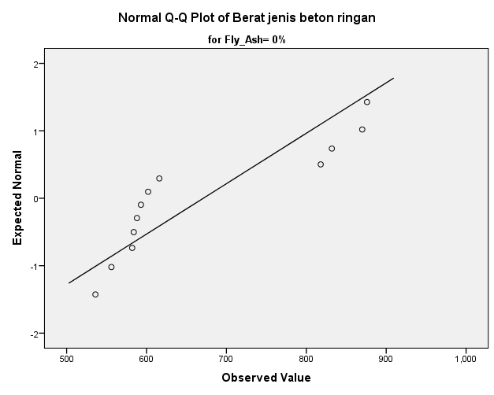

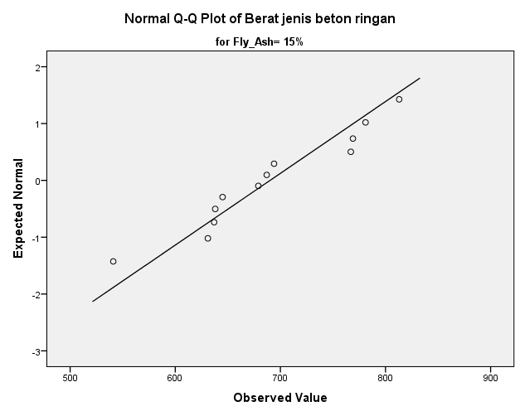

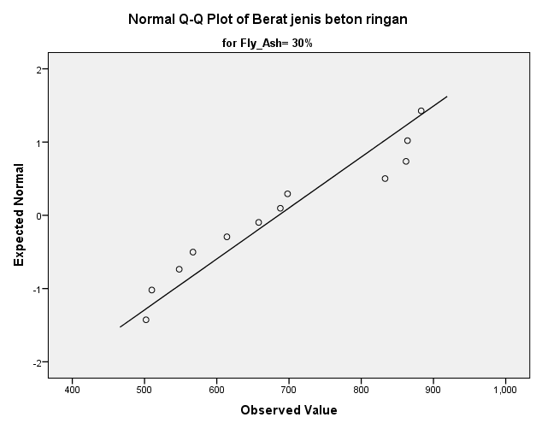

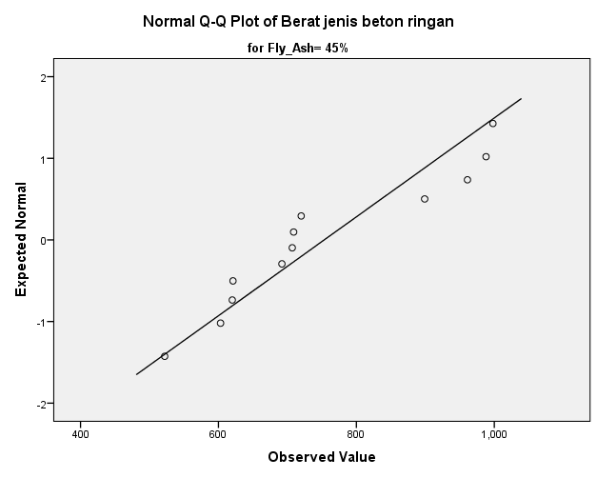

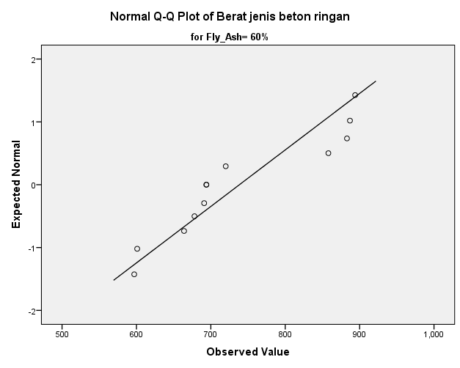

Detrended Normal Q-Q Plots

